GOD CARES RIGHTS FOUNDATION ORGANISATION

COVID-19 PREVENTION TRAINING AND PIG PRODUCTION SENSITIZATION FOR SCHOOL FOR THE BLIND LEARNERS` PARENTS/GUARDIANS

CONDUCTED AT

EKWENDENI SCHOOL FOR THE BLIND MIN HALL
EKWENDENI CCAP PRIMARY SCHOOL

Submitted to: The Executive Director
God Cares Rights Foundation
Post Office Box 210
Ekwendeni

Cc: Field Officer

Submitted by: The Project Officer
God Cares Rights Foundation

Date Submitted 17/06/2020

- INTRODUCTION
God Cares Rights Foundation conducted COVID 19 training on 11^{th and} 12th June, 2020, at Ekwendeni School for the Blind Min Hall. The training was ear marked for 10 parents (6 female and 4 male) the most vulnerable parents and guardians of learners at Ekwendeni School for the Blind. These were supported with pigs as an economic empowerment that will necessitate continued care for their physically impaired children (with albinism, partial and total blind) as they learn at Ekwendeni School for the Blind. The targeted beneficiaries were previously trained in business management and pig farming and later were given pigs to be raised in their homes. Trained participants were drawn from Zowe, Sokopo, Mtwalo, Matindiwizi, Thunduwike, Engucwini, Chiziweni, Chilida, Chimozimodzi and Enukweni in the school catchment area.
The main objective of the training was to prepare participants on preventive measures to COVID 19 that would benefit their children with visual impairment who learn at Ekwendeni School for the Blind.
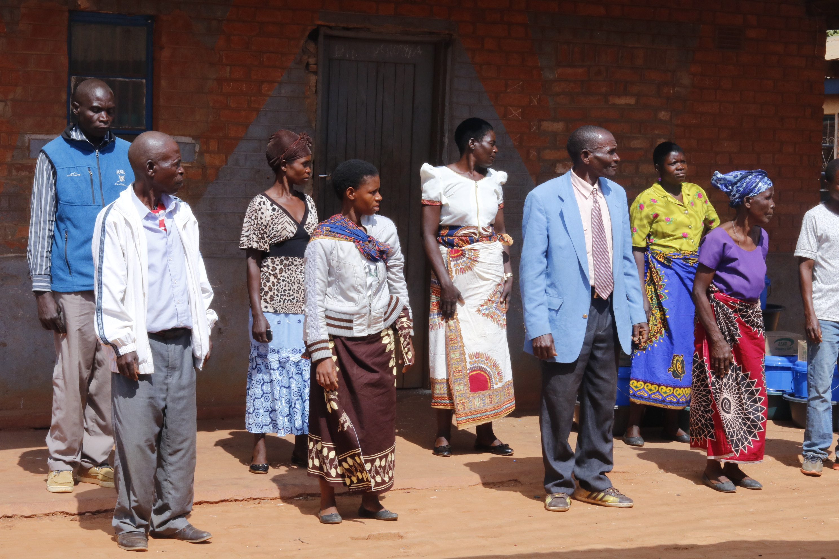
Fig 1: Parents/guardians of visually impaired school learners at Ekwendeni School for the Blindwho came for training
- Training objective
To train guardians/parents on COVID-19 prevention and pigs management.
2.1 Specific Objectives
- Participants flash backs on the pig management training
- Participants oriented on COVID 19 outbreak and prevention measures.
- Provision of hand washing buckets and soap

- The training was conducted for two days, first day it was pigs management next day COVID 19 prevention
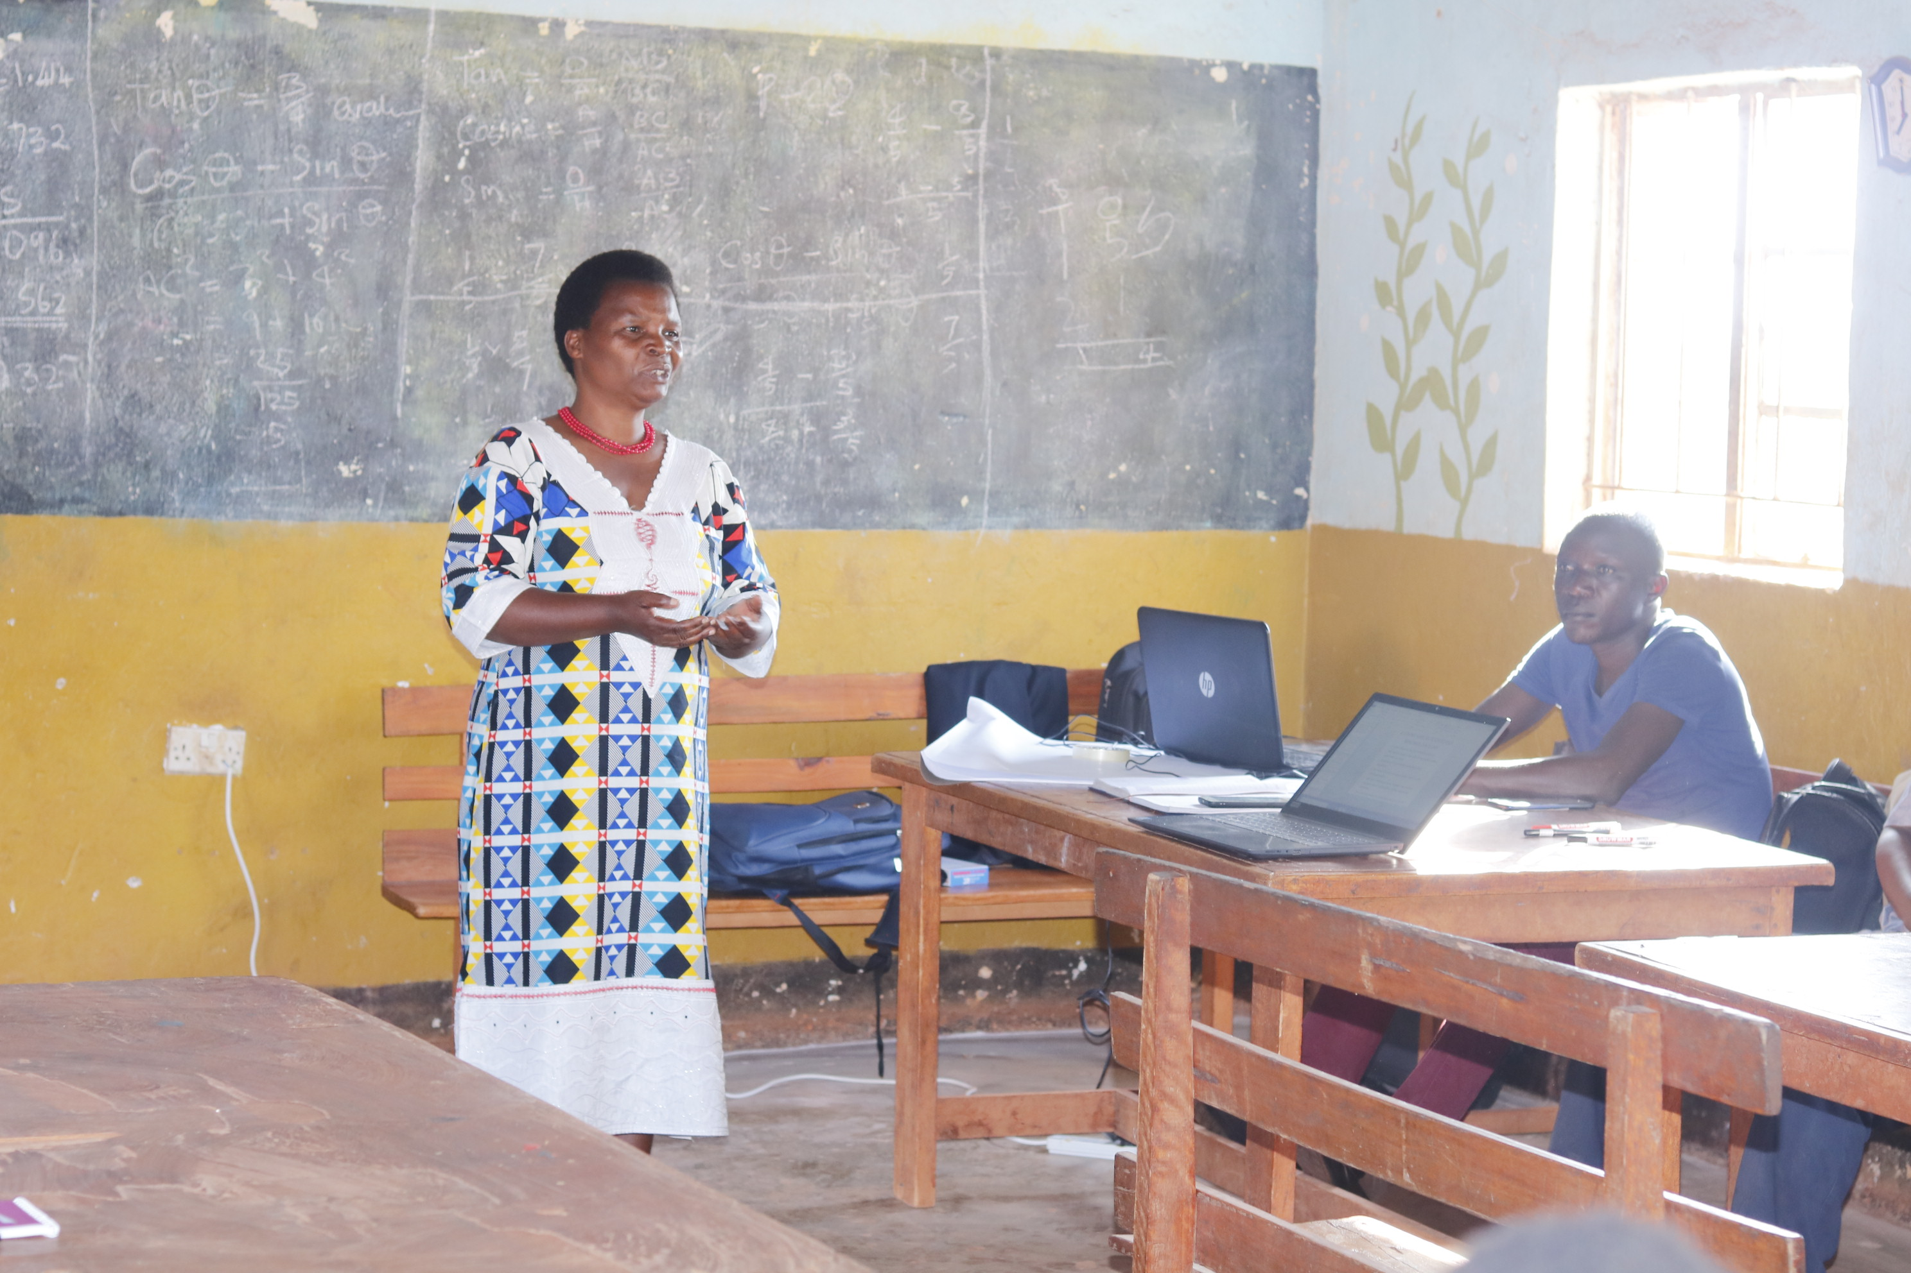
Fig 2: God Cares Rights Foundation Executive Director giving training opening remarks

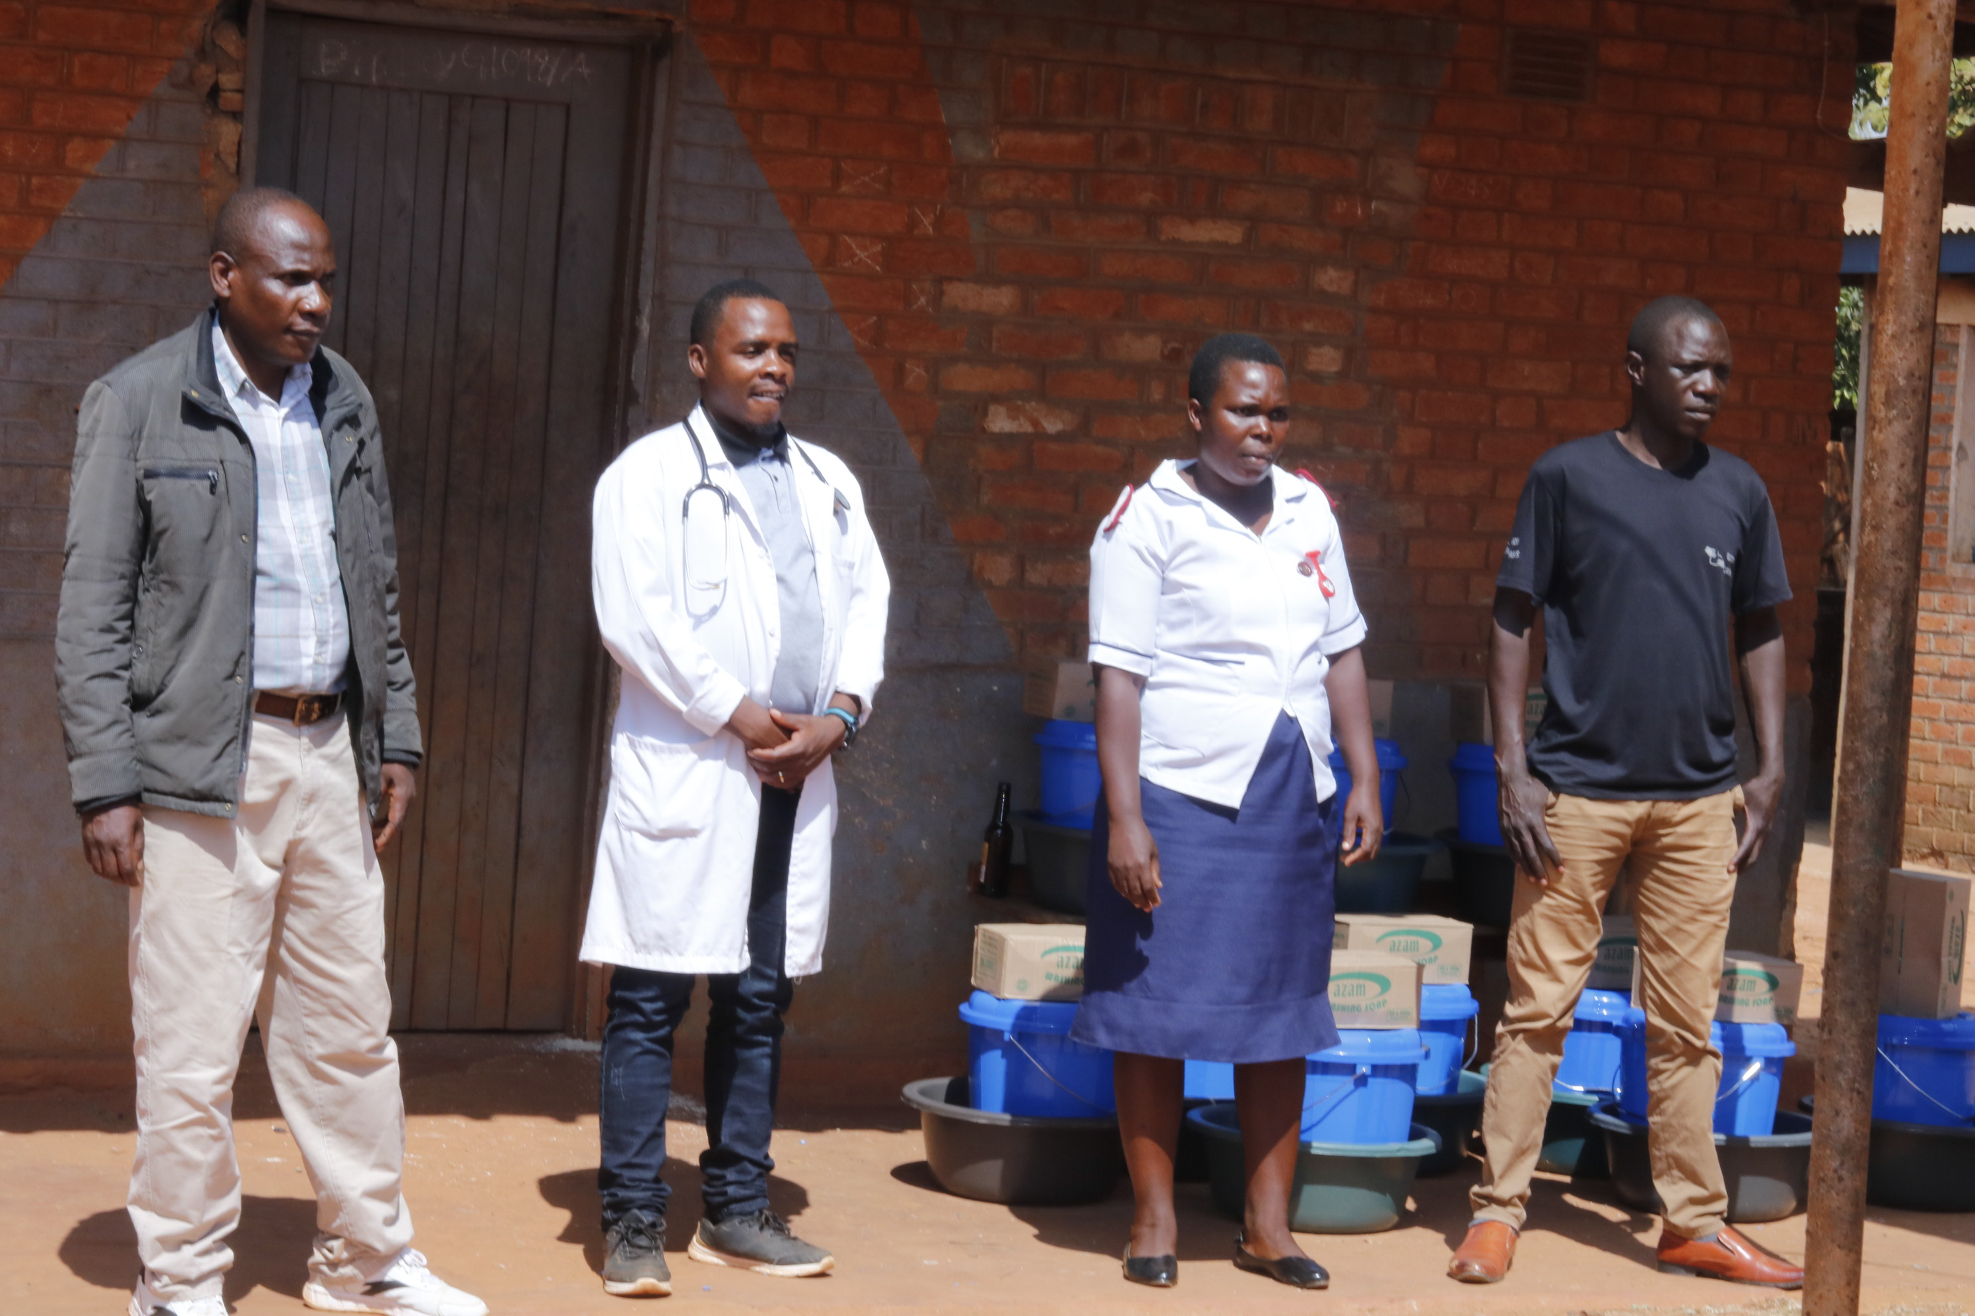
Fig 3: The four training facilitators on the middle are two health personnel training participants on COVID-19 prevention, the other two from God Cares, training participants on pigs management.
  - Pig Management training feed back
The training workshop was done in two days in order to achieve the intended goal. The first day was for pig production and management practices followed by COVID 19 prevention on the next day. Venue for the training was at Ekwendeni School for the Blind Mini Hall. There were 10 participants in the training from the most vulnerable households targeted for support. Participants called for the training were those offered with pigs in the month of March, 2020. They were trained in pig management for profit making in order to boost economy of their households where the vulnerable school for the blind learners come from. During the first training winding up, participants were assigned tasks to accomplish in the course of pig production like feed reserving/ budgeting for pigs, pig vaccination, following up pig on heat signs and receiving pig health conditions.
The first day of the training was taken by Blesco Nyangulu and Sam Sambo as agriculture specialists. Participants in review were taken through lessons revisions on how they relate between theory they had in training and pig practical rearing provided. It was interesting to note that participants were able to give testimonies that their pigs were responding well following management practices acquired. On feed budgeting, participants expressed ignorance on the feed calculation and projections. Upon calculations as each pig grown up consumes 2.5kg per day would like to keep 75 kilograms of feed per months translating to 900 kilograms per year. All pigs were reported alive but one belonging to Upile Mkonda died unexpectedly and the community through the local leader sat down and contributed money. Through the contributed money they bought Upile Mkonda a replacement pig. That was commendable, the community initiative taking part in the program as a way of ownership.
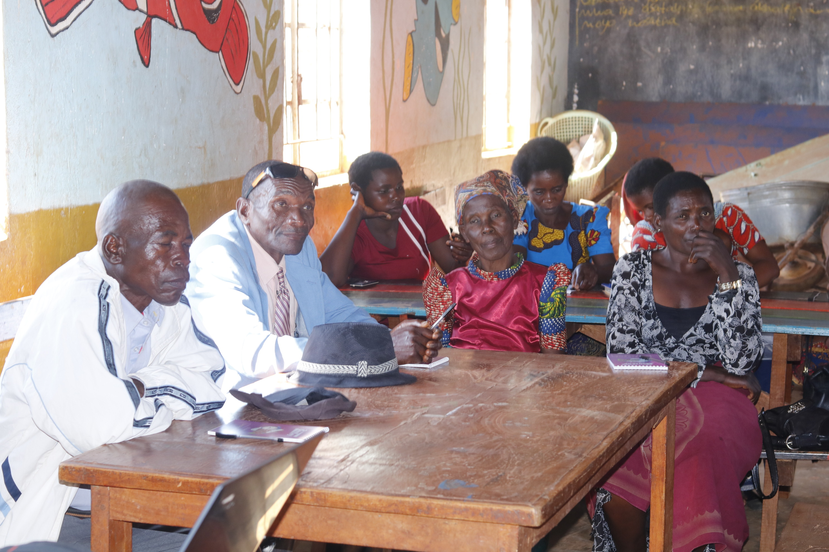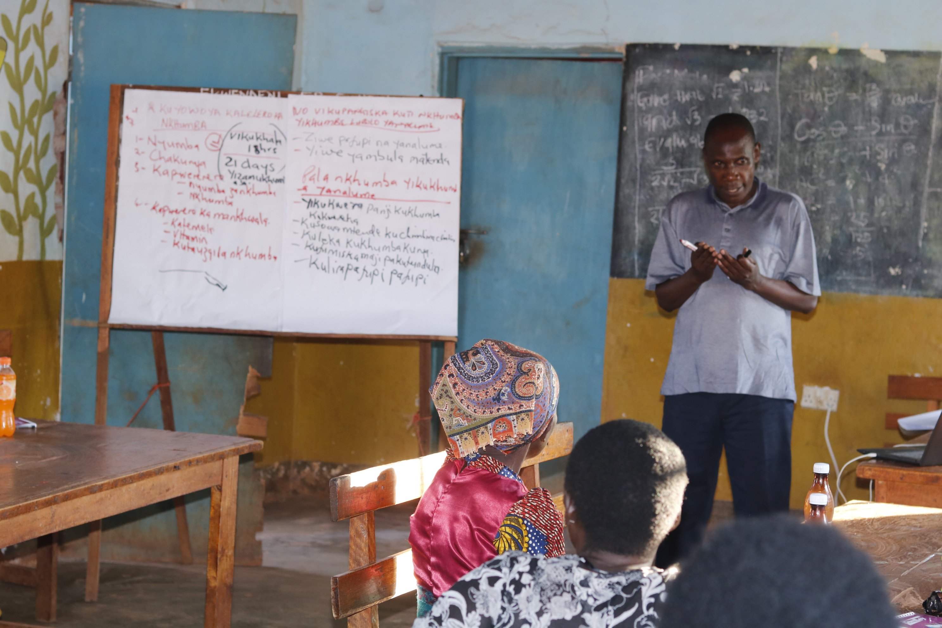
Fig 4: Pig production training review with participants on 11th June, 2020
  - COVID 19 training
COVID 19 pandemic lessons were facilitated by Clinician Glandson Chirwa and Nurse Siphiwe Kachilika both staffs from Ekwendeni Mission Hospital trained in the field of clinical medicine and COVID 19. Lessons were shared well amongst themselves who incorporated demonstrations with vast experience in the field of delivery. Most of the outcomes were received through active participation from the participants. The facilitation process used approved Ministry of Health and Population COVID 19 Clinical Case Management May 2020, Manuals. The training was in class and demonstrations on how to prevent CVID 19. Participants were taken through the concept of COVID 19 pandemic transmission and prevention measures. Participants were taken through the concepts of COVID 19 on scanning, brief history of the pandemic, contacting methods, spreading measures, signs and symptoms of corona virus, prevention measures and demonstrating preventing measures such as hand washing, face masks, and making of hand sanitizers.

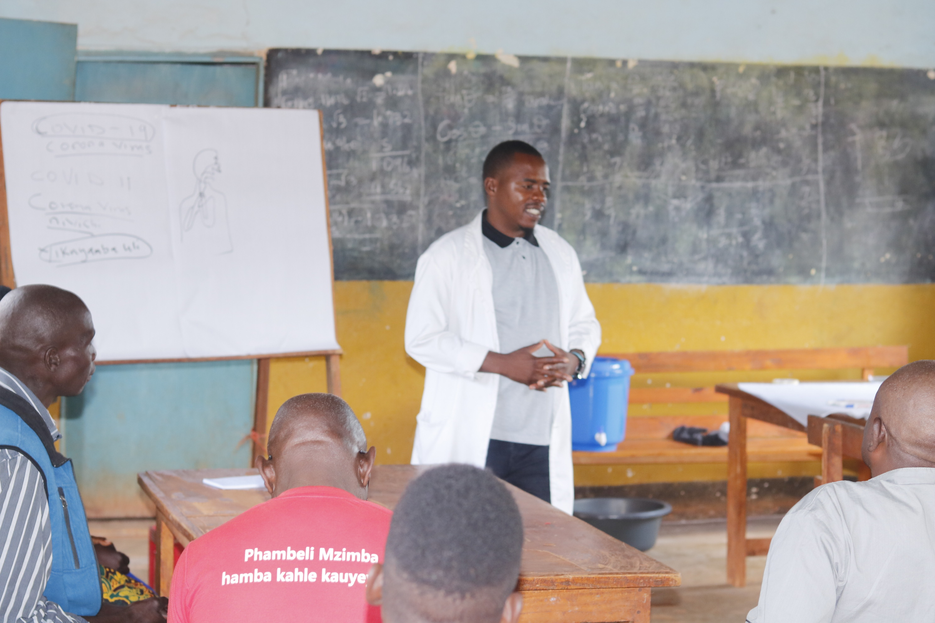
Fig 5: Clinician giving COVID 19 lessons to trained participants
The training on COVID 19 prevention was attended by 14 participants (8 female and 6 male) which included 4 Ekwendeni Primary School teachers administrators.
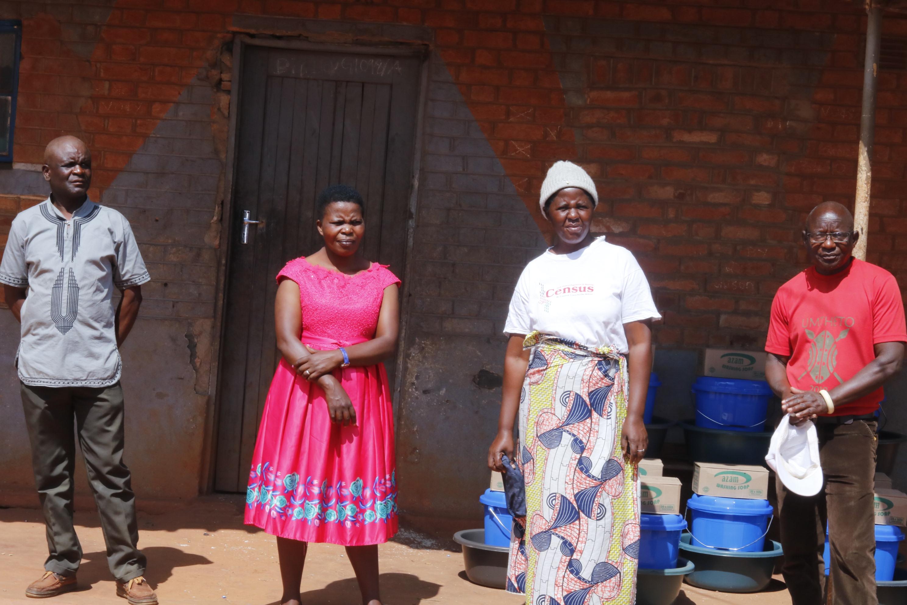
Fig 6: These are the four school representatives who attended COVID 19 training prevention from Ekwendeni CCAP Primary School. Left is Mr Chibambo, school for the blind boarding master, in Red dress is the deputy head for Ekwendeni Full primary School, in white t-shirt is the school for the blind teacher in charge and in red t-shirt is the head teacher for Ekwendeni full primary school
  - Provision of hand washing and soap facilities
From the demonstrations made participants were provided with hand washing facilities to carry to their homes for their families to use including the visually impaired. That was made following the vulnerability and financial incapacitation of the targeted households. Participants excluding teachers received each 30 of 140 grams bars of soap, a hand washing plastic bucket and washing basin each.
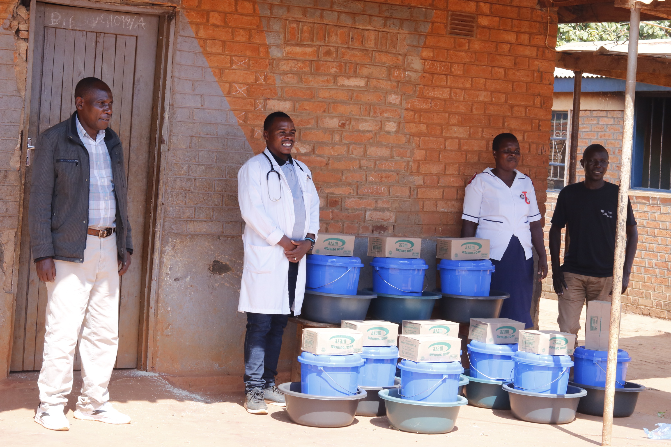
Fig 7: Hand washing facilities and cartons of 30 each bars of soap for COVID 19 prevention
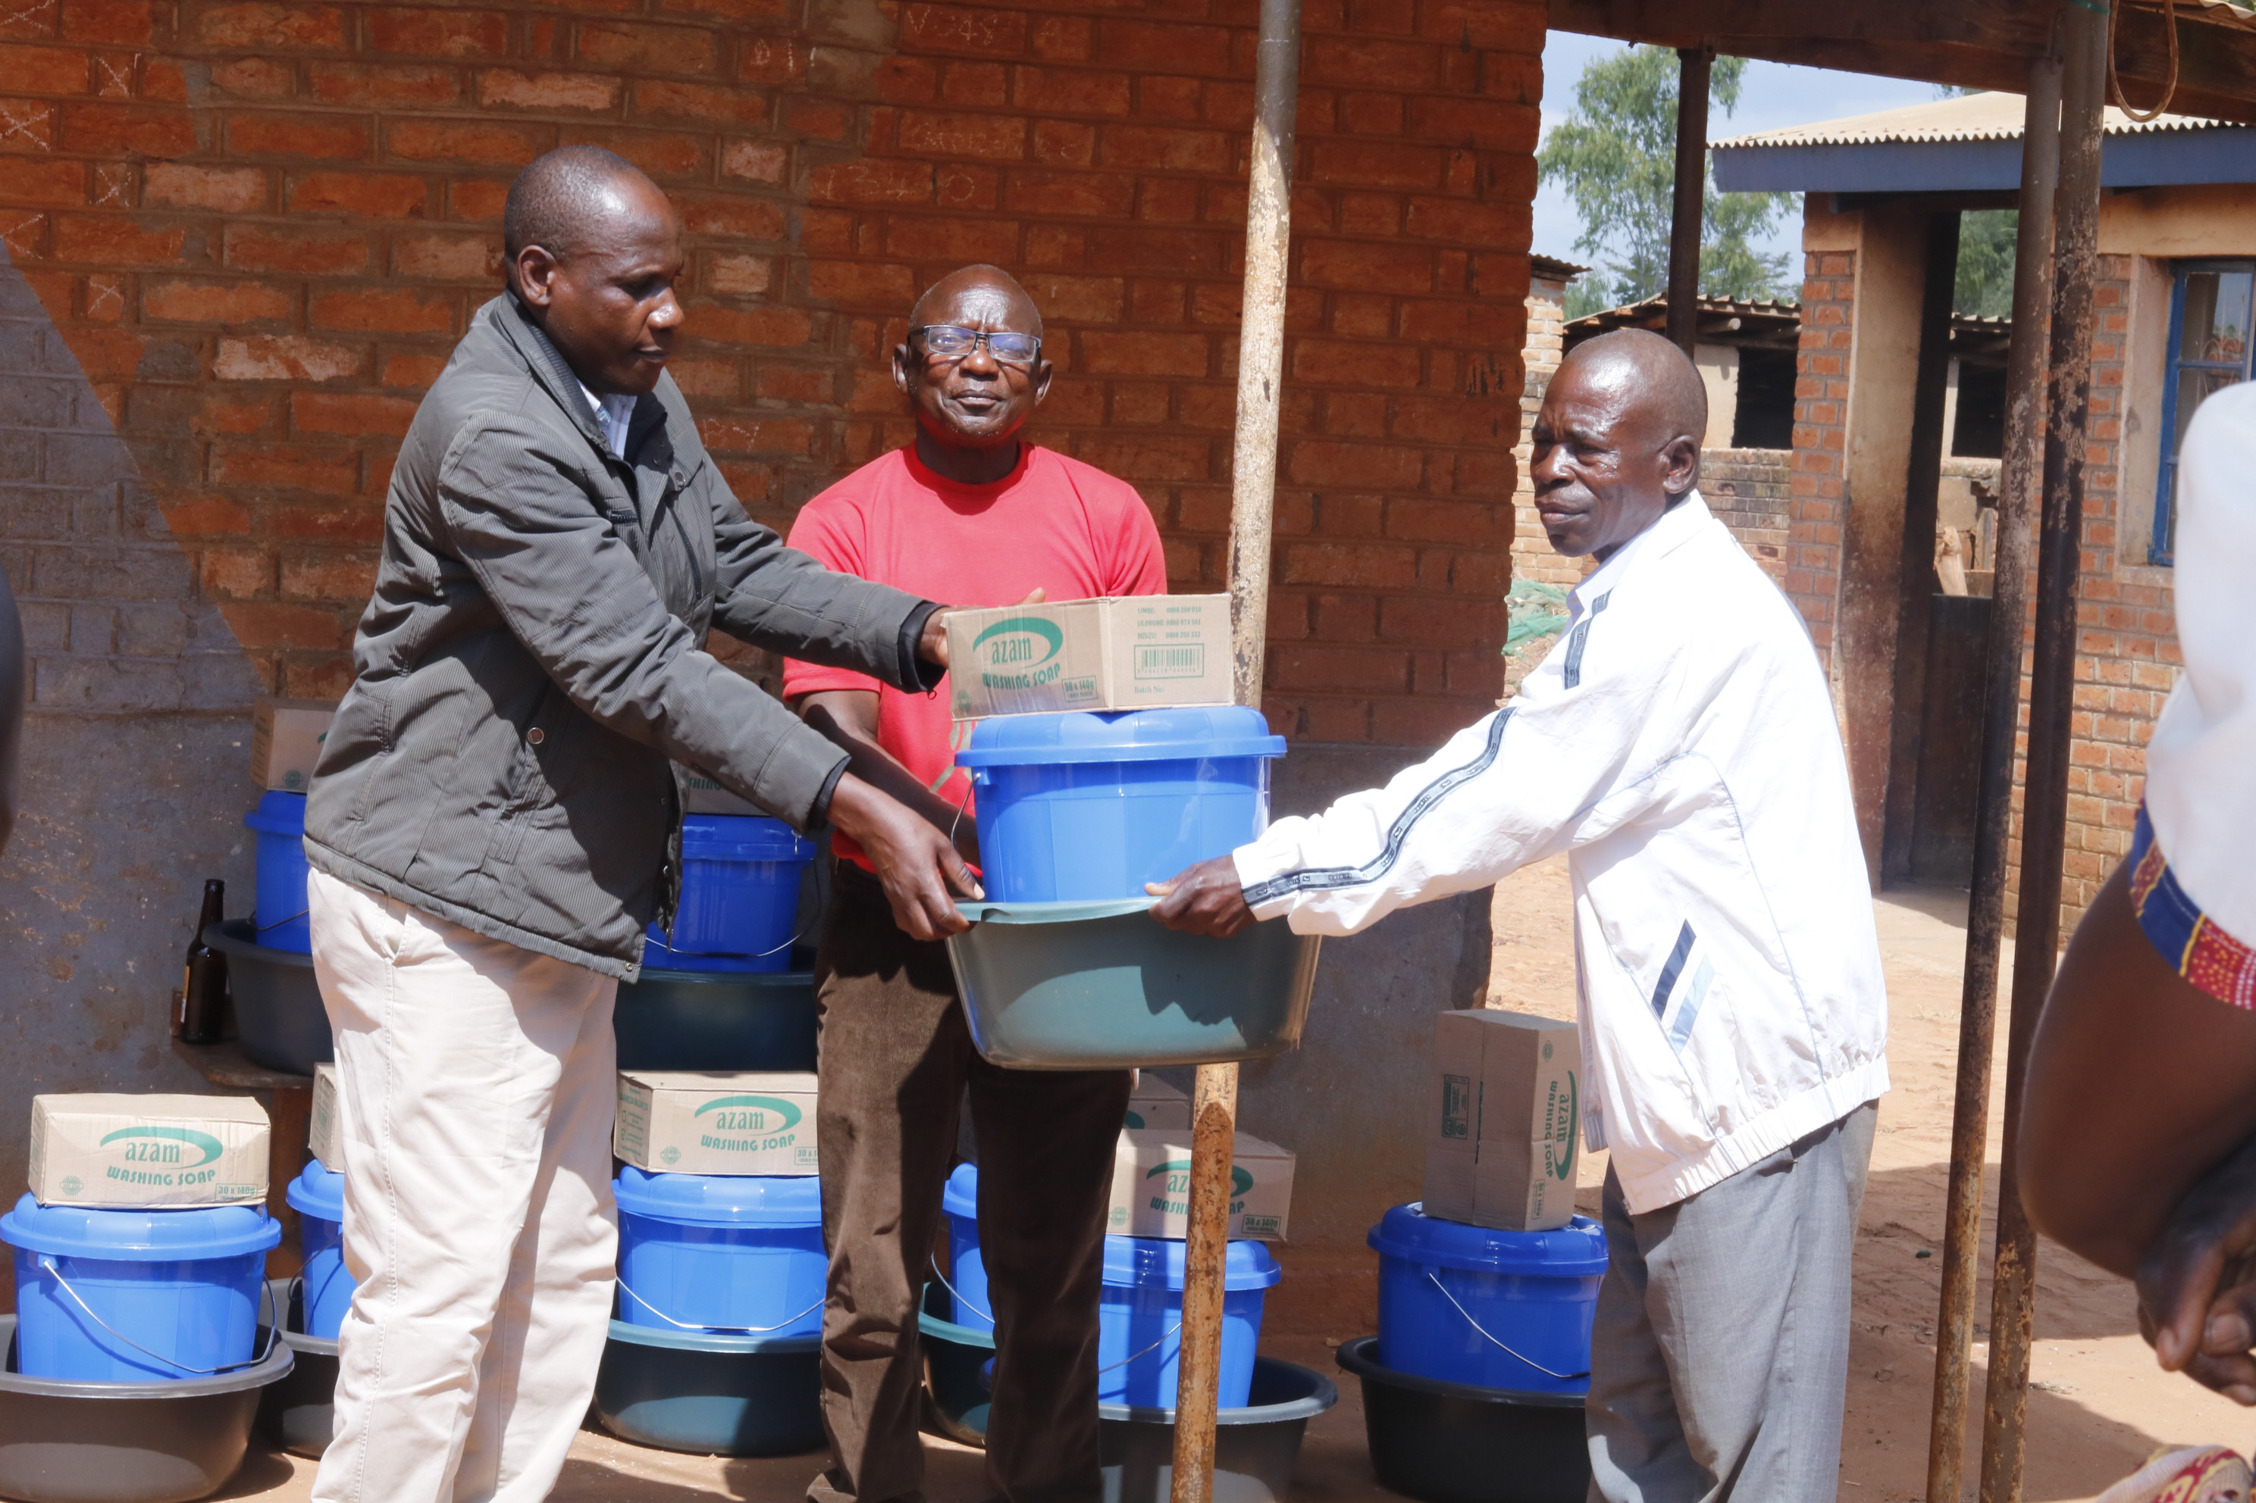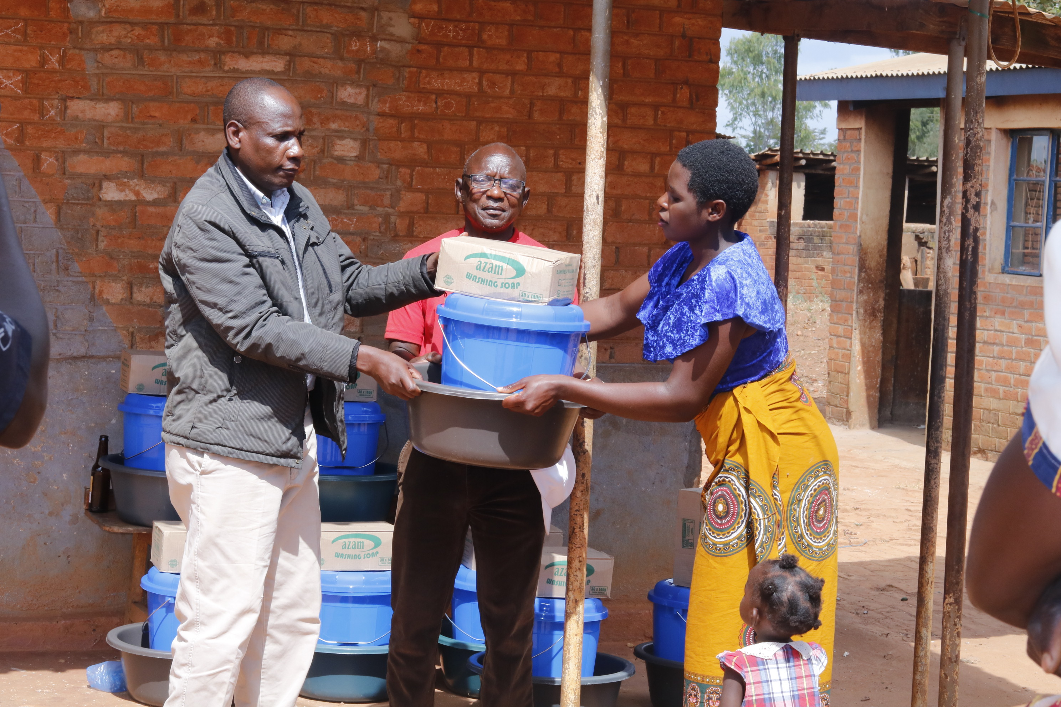
Fig 8: Participants receiving hand washing facilities after the training
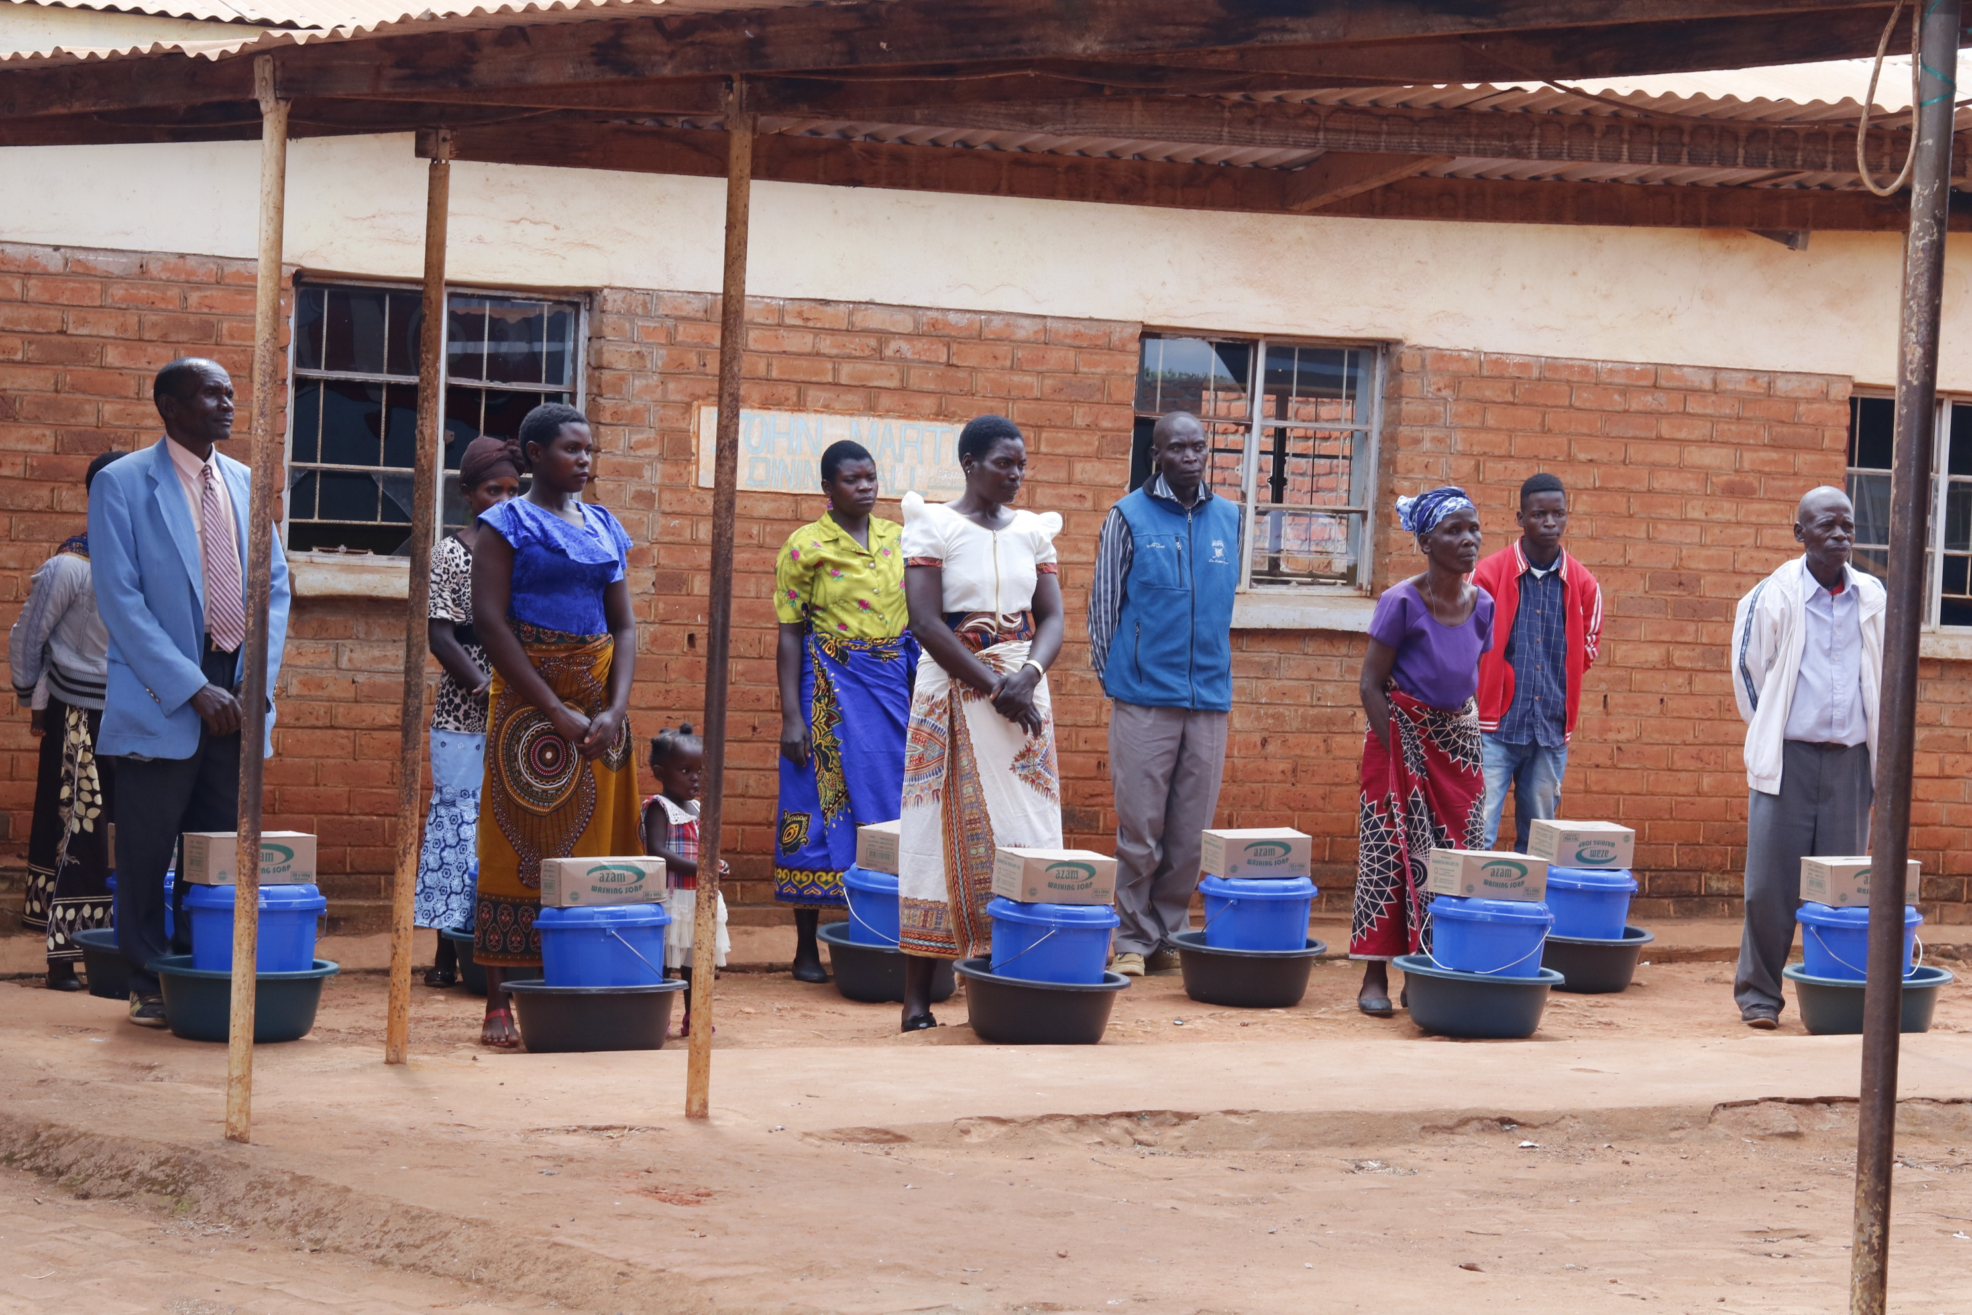
Fig 9: Trained participants taking a group photo with their hand washing packs
- Vote of Thanks
The trainers thanked God cares for the training, they said that they were not aware that COVID 19 was a disease that would be transmitted even to those living in villages. They said that they share with their communities what they learnt. They were also very thankful for protection packs which they received. They appreciated the organization of the training, that it hard all training requirements including plastic basin filled with water, basin and soap for washing hands. They said that the training on how to fix pale taps in case it is loose was very important because they shall be able to fix their pales themselves.

